Bridge Math Solving Systems of Equations by
Elimination & Substitution

Name: ____________________________________ Class: __________________

Solving Linear Systems by Substitution
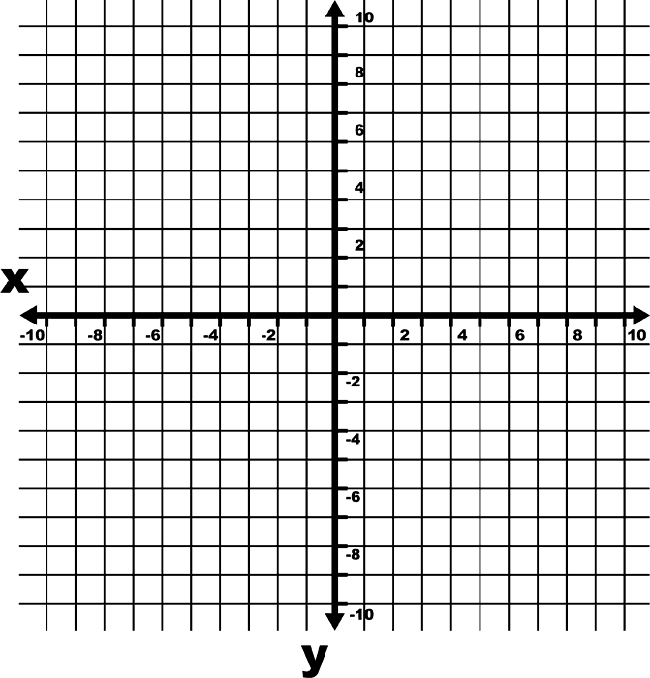
1. $\left\{\begin{aligned}y=-3x+5 \\ y=4x-9\end{aligned}\right.$

2. $\left\{\begin{aligned}y=2x-1 \\ 3x+2y=26\end{aligned}\right.$

DSPM 0800 – Elementary Algebra Solving Systems of Equations by
Elimination & Substitution

Name: SOLUTIONS Class: __________________

Solving Linear Systems by Substitution
1. $\left\{\begin{aligned}y=-3x+5 \\ y=4x-9\end{aligned}\right.$

2. $\left\{\begin{aligned}y=2x-1 \\ 3x+2y=26\end{aligned}\right.$

3. $\left\{\begin{aligned}5x+6y=-9 \\ 2x-2=-y\end{aligned}\right.$

4. $\left\{\begin{aligned}-4y=x \\ 2x+6y=-3\end{aligned}\right.$

5. $\left\{\begin{aligned}2x+y=1 \\ 2x+y=5\end{aligned}\right.$

6. $\left\{\begin{aligned}2x-y=4 \\ -2x+y=-4\end{aligned}\right.$

Solving Linear Systems by Elimination
7. $\left\{\begin{aligned}x+5y=28 \\ -x-2y=-13\end{aligned}\right.$

8. $\left\{\begin{aligned}\frac{3}{2}x+y=-\frac{5}{2} \\ 4x+y=-5\end{aligned}\right.$

9. $\left\{\begin{aligned}7x-\frac{1}{3}y=-29 \\ 2x-\frac{1}{3}y=-9\end{aligned}\right.$

10. $\left\{\begin{aligned}-3x-y=-15 \\ 8x+4y=48\end{aligned}\right.$

11. $\left\{\begin{aligned}9x-4y=26 \\ 18x+7y=22\end{aligned}\right.$

12. $\left\{\begin{aligned}3x+2y=4 \\ -6x-4y=-8\end{aligned}\right.$

13. $\left\{\begin{aligned}3x+y=4 \\ x+\frac{1}{3}y=2\end{aligned}\right.$

14. $\left\{\begin{aligned}-3x+4y=2 \\ 2y=\frac{3}{2}x+1\end{aligned}\right.$

15. $\left\{\begin{aligned}-6x+6y=-4 \\ 2x-2y=5\end{aligned}\right.$

Graph the linear system, then use the graph to tell whether the linear system has one solution, no solution, or infinitely many solutions.

16. $\left\{\begin{aligned}-6x+2y=-2 \\ -3x+y=2\end{aligned}\right.$ 17. $\left\{\begin{aligned}-\frac{2}{3}x+y=2 \\ -6x+3y=6\end{aligned}\right.$ 18. $\left\{\begin{aligned}y+3=4x \\ 3y=12x-9\end{aligned}\right.$

Vocabulary
Use the vocabulary terms listed below to complete each statement.

system of linear equations solution of the system inconsistent system
solution set of the system consistent system independent equations
dependent equations

1. Equations of a system that have different graphs are called __________________.

2. A system of equations with at least one solution is a ___________________.

3. The set of all ordered pairs that are solutions of a system is the _______________________.

4. The _______________________________ of a linear equations includes all the ordered pairs that make all the equations of the system true at the same time.

5. Equations of a system that have the same graph (because they are different forms of the same equation) are called _____________________________.

6. A system with no solution is called a(n) __________________________.

7. A(n) ________________________________ consist of two or more linear equations with the same variables.

